# Nightfire Retro High-Tops

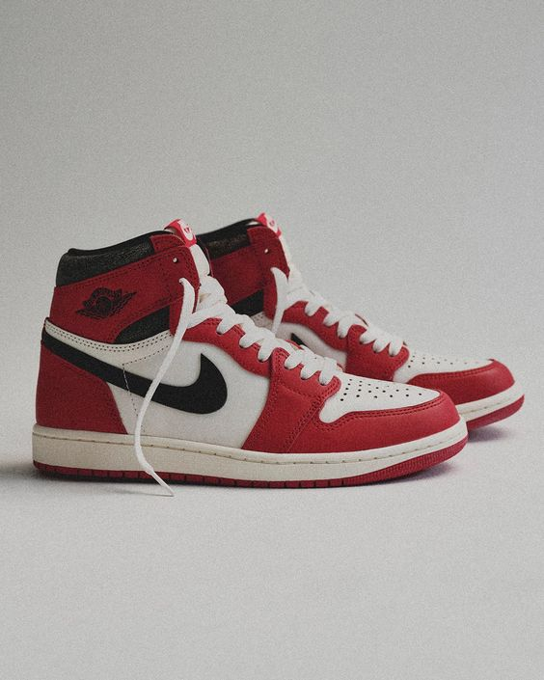

Product Details:

Color Combination: The Jordan Nightfire Retro High-Tops feature a striking color combination including deep crimson re), midnight black, and cool grey.

Material: Crafted from premium synthetic leather and durable textile materials, ensuring both style and longevity.

Sole: Boasting a cushioned and responsive sole unit, providing optimal comfort and support during wear.

Closure: Secure lace-up closure system for a personalized and secure fit.

Branding: Iconic Jumpman logo detailing prominently displayed on the tongue and heel, showcasing the shoe's authentic Jordan heritage.

Comfort: Padded collar and cushioned insole offer exceptional comfort, making them perfect for all-day wear.

Style: The Jordan Nightfire Retro High-Tops blend retro design elements with contemporary aesthetics, making them a versatile addition to any sneaker collection.

Occasion: Ideal for both casual outings and semi-formal occasions, these high-tops add a touch of athletic-inspired style to any ensemble.

Versatility: Pair with jeans, joggers, or even a casual suit for a fashion-forward look that's sure to make a statement both on and off the court.